
2025- 2026 Semi 2
Higher Diploma in Computer Studie



Program Code: HDPCSMAGD
Subject Code: 03CIT4090
Lecturer Name: Stephen NG
Group 4 Members: Li Shimin, Lam Man Ho

Part A:

Q1a. The hostname should be named in primary + <group number> format. E.g. primary0
- Marking criteria: Show the correct hostname (5%)

Q1a Answer. (answer with a single image)
$ ls -ld /lost+found


Q1b. The username should be named in group + <group number> format. E.g. group0
- Marking criteria: Show the correct username (5%)

Q1b Answer. (answer with a single image)
$ ls -ld /lost+found/ && sudo tail -n 2 /etc/shadow
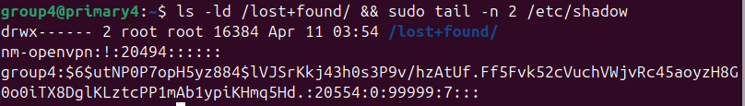

Q2. Network settings
In the primary Linux server, create a Host-only network and set up a static IP address by netplan.
- Static IP address: 192.18.56.210+<group number>. E.g. Group0 = 192.168.56.210
- Marking criteria: Show the correct IP address (3%) and ping it successfully (2%)

Q2 Answer. (answer with a single image)
$ ip address show enp0s8 && ping 192.168.56.1 -c 2
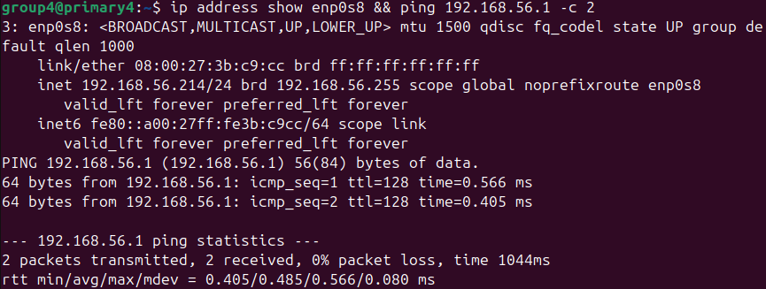

Q3. Web Server
In the primary Linux server, create a web server with the following requirements:
- Hostname: newsme+<group number>.com. E.g. newsme0.com
- Enable SSL
- Document root: /var/www/newsme+<group number>.com. e.g. newsme0.com
- Testing by browsing https://www.newsme0.com/phpinfo.php
- phpinfo.php: <?php phpinfo(); ?>
- Marking criteria: Show the correct https protocol (2%) and the website content (3%)

Q3 Answer. (answer with a single image)
Firefox: https://www.newsme0.com


Q4. NFS Server
Create a “secondary” Ubuntu Linux server named secondary+<group number> and
- In the primary Linux server, setup a NFS Server and a shared directory (/var/www/newsme0.com)
- In the secondary Linux server, mount the shared directory from the primary Linux server to /mnt/newsme0.com
Marking criteria: Show the primary Linux NFS settings (3%) and the secondary Linux settings (2%)

Q4 Answer. (answer with a single image)
In primary Linux
$ ls -l /var/www/newsme0.com && showmount –exports

In secondary Linux
$ ls -l /mnt/newsme0.com && showmount –exports 192.168.56.<primary>

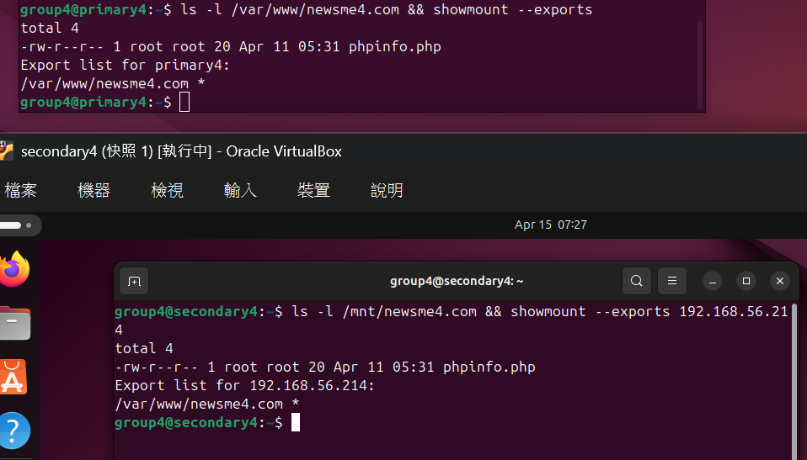

Q5. SSH Server
In the primary Linux server, set up an SSH server and update the login banner to display your group+<number >.
- Use this website (http://patorjk.com/software/taag/ ) to create ASCII text.
Marking criteria: In the secondary Linux server, run the SSH client to connect to the primary SSH server (3%) with the correct login banner display (2%)

Q5 Answer. (answer with a single image)
In secondary Linux
$ ssh 192.168.56.<primary>

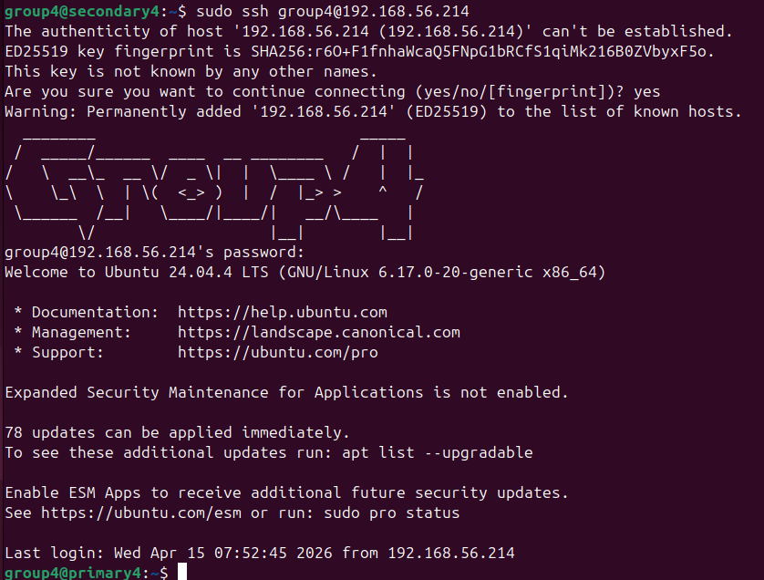

Q6. User account
In the primary Linux server, create a user account named peter with the following configurations:
- Set peter as sudoer
- Peter belongs to the marketing group
Marking criteria: Show the correct sudoer user right (3%) and the belonging group (2%).

Q6 Answer. (answer with a single image)
$ sudo cat /etc/passwd | grep peter && cat /etc/group | grep peter
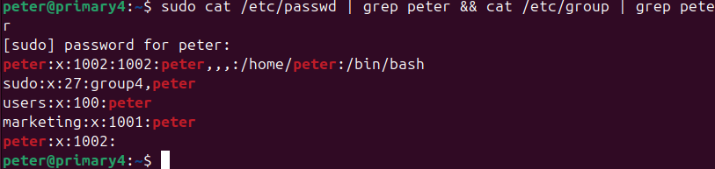

Q7. Permission
In the primary Linux server, create the /home/sales directory with the following permissions:
- Owner can have full access
- Group can have full access
- Other users do nothing about it.
- SGID + Sticky Bit
Marketing criteria: Show the correct permission (3%) and the super permission (2%)

Q7 Answer. (answer with a single image)
$ ls -ld /home/sales

Q8. Backup & Cronjob
Q8a. Create a shell script file named backup.sh to back up the sales directory to /home with the following requirements:
- Backup script file location: /home/backup.sh
- Archive file location: /home/sales_yyyy-mm-dd_HH.MM.ss.tar.gz
- Marking criteria: Show the correct archive file. (5%)

Q8a Answer. (answer with a single image)
$ date && ./backup.sh && ls -l /home/*.tar.gz
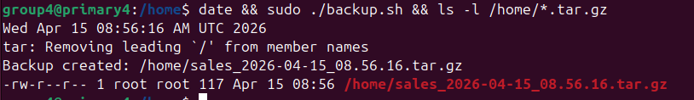

Q8b. Schedule a cronjob to execute the Q8a shell script every minute.
Marking criteria: Show at least two continued archive files. (5%)

Q8b Answer. (answer with a single image)
$ date && sudo crontab -l | tail -n 1 && ls -l home/*.tar.gz
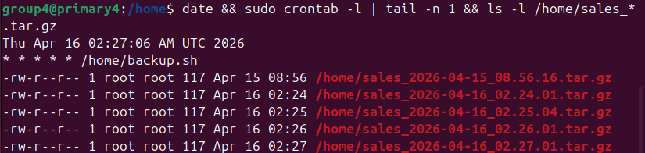

Part B:
In this section, we have built serval service to the primary server. Including:
- Git (similar to combination of SSH + NFS)
- Nginx Web (similar to Apache server)
- UFW Firewall
- Fail2ban

Student/Team: LiShimin / Group 4
Primary Server (Git + Nginx): primary4
Secondary Server (Git client): secondary4
Service Summary: We implemented a self-hosted Git server on the Primary server and integrated it with a Nginx web service. When developers push updates from the Secondary server, the website on the Primary server is automatically updated via a Git hook.

Benefits
2.1 Benefits of Git (Self-hosted)
Version control & history: Every change is tracked with commit history, enabling rollback and auditing.
Collaboration: Multiple team members can work on the same project, merge changes, and avoid overwriting each other’s work.
Central repository: The Primary server acts as a central repository for internal projects, improving organization and standardization.
Security & internal control: Hosting Git internally keeps source code within the company network (useful for SMEs).

2.2 Benefits of Nginx Web Service
Fast and lightweight web server: Nginx is known for high performance and low resource usage.
Easy virtual host configuration: We can host multiple sites/ports with different configurations.

2.3 Benefits of Git + Nginx Integration (Auto-Deploy)
Automated deployment: After a git push, web content updates automatically without manual copying.
Reduced human errors: Eliminates mistakes from manual uploads (missing files, wrong versions).
Faster update cycle: The website can be updated quickly during development and testing.

Git: Self-hosted Git repository on the Primary server
Git Installation (Primary server):
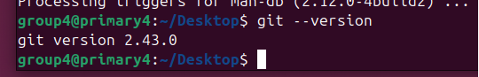
1. Use “$sudo apt install” to install Git service:
$ sudo apt update
$ sudo apt install git -y
2. inspectGit version:
$ git --version
Create repository:
1. Create Git repository directory
$ sudo mkdir -p /srv/git/project.git
2. Enter Git repository directory:
$ cd /srv/git/project.git
3. Initiate an empty repository:
$ sudo git init --bare
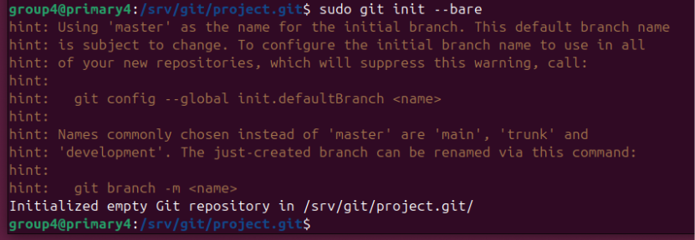
4. Change own for repository:
sudo chown -R group4:group4 /srv/git/project.git
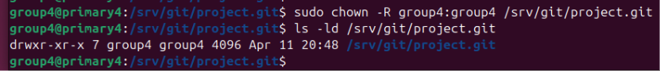

Cloning repository in primary server to secondary server (secondary4):
1. git clone group4@192.168.56.210:/srv/git/project.git
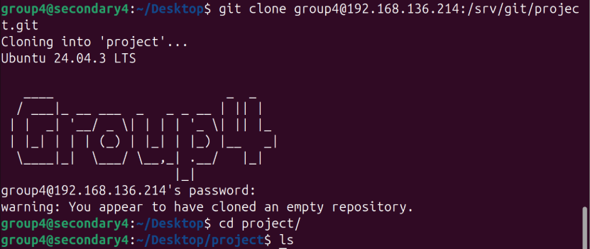

Test “Submit” & “Push”
1. Entering repository and create a file or document:
$ cd project
$ echo "<h1>Hello Git + Web</h1>" > index.html
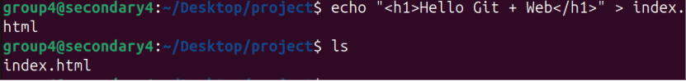
2. Create Git user information:
git config --global user.name "group4"
git config --global user.email "group4@git.com“
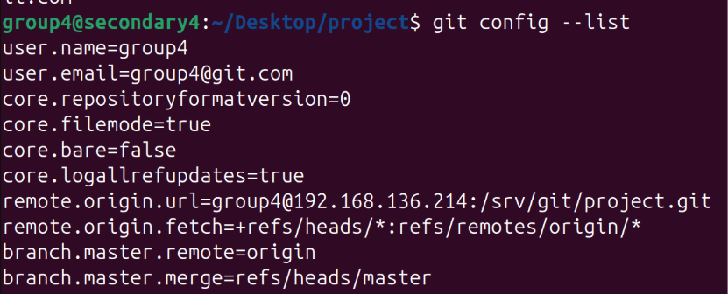
3. Adding documentation to holding area then push to main server (primary)
$ git add index.html
$ git commit -m "Add index.html"
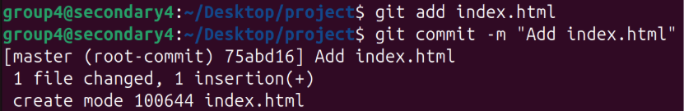
$ git push origin master
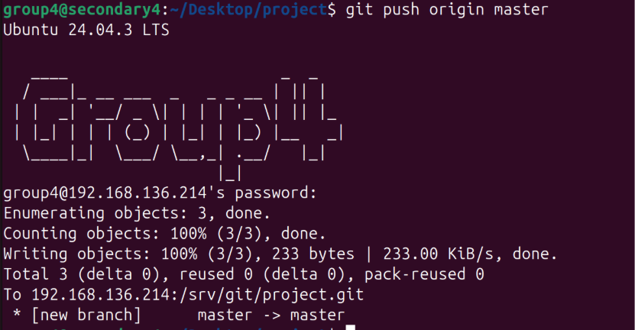

Nginx Web:
Installing Nginx Web:
1. Install through apt install:
$ sudo apt update
$ sudo apt install nginx -y
2. Inspect server status:
$ sudo systemctl start nginx
$ systemctl status nginx
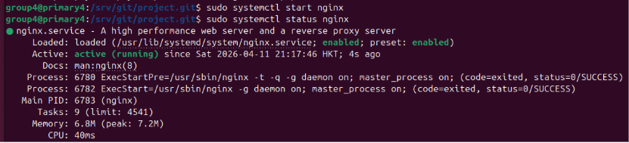

Create DocumentRoot:
1. Create directory for storing web documents:
$ sudo mkdir -p /var/www/gitweb
$ sudo chown -R group4:group4 /var/www/gitweb
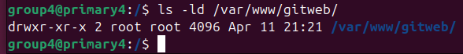

Set up virtual environment for Nginx:
1. Create config files:
$ sudo nano /etc/nginx/sites-available/gitweb.conf
nano:

server {
listen 8080;
server_name www.gitweb.local;

root /var/www/gitweb;
index index.html;
}
2. Enable site:
$ sudo ln -s /etc/nginx/sites-available/gitweb.conf /etc/nginx/sites-enabled/
- Check if config is correct.
$ sudo nginx -t
- Reload Nginx setting:
$ sudo systemctl reload nginx
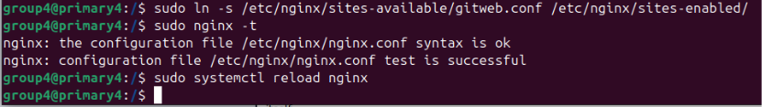

Site Testing:
1. Set up DocumentRoot
sudo nano /etc/hosts
nano:
192.168.136.214 www.gitweb.local

Git push and collaborate with Nginx:
1. Entering repository
$ cd /srv/git/project.git/hooks
2. Create and nano:
$ sudo nano post-receive
nano:
#!/bin/bash
TARGET_DIR=/var/www/gitweb
GIT_DIR=/srv/git/project.git

# 清空目标目录（避免旧文件残留）
rm -rf $TARGET_DIR/*

# 检出最新版本到目标目录
git --work-tree=$TARGET_DIR --git-dir=$GIT_DIR checkout -f

# post-receive: automatically runs the program
# GIT_WORK_TREE=/var/www/gitweb：declare working area to Nginx’s DocumentRoot.
# git checkout -f：push latest version to root
3. Give script “execute” permission
$ sudo chmod +x post-receive
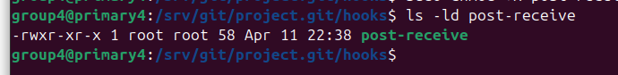
4. Provide permission for directory:
$ sudo chown -R group4:group4 /var/www/gitweb
Collaboration test:
1. Upload resources:
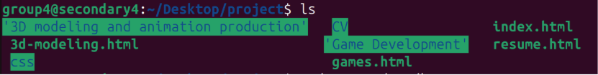
2. Submit and push
$ git add .
$ git commit -m "Add project files"
$ git push origin master
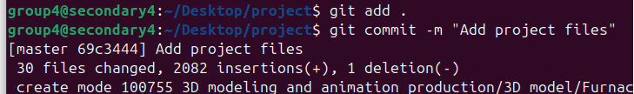
3. Enter web address:
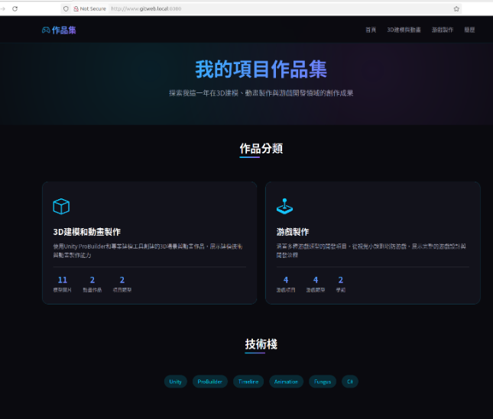

Student/Team: Lam Man Ho / Group 4
Service Summary: We implemented a host-based firewall using UFW (Firewall) to reduce the server’s attack surface. The default policy is set to deny all incoming connections and allow all outgoing connections as lecture notes; then only necessary service ports are explicitly allowed. Also, we have implement a Fail2ban service for advanced protection, this improves security and provides best practices for server administration.

Set up UFW:
1. Reset UFW to have a clean start:
$ sudo ufw reset
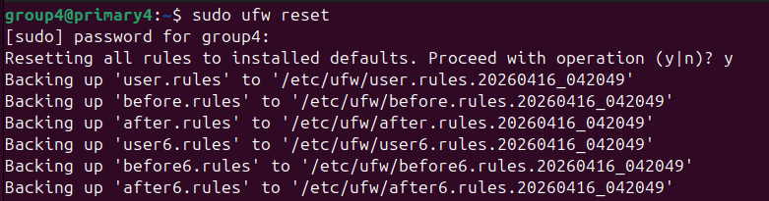
2. Set default policy:
$ sudo ufw default deny incoming
$ sudo ufw default allow outgoing


3. Allow SSH access (SSH in Part A, also Git service uses SSH port):
$ sudo ufw allow ssh
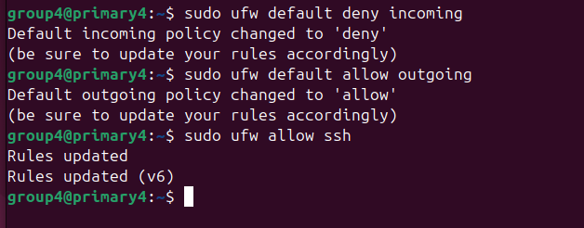
4. Allow the server port we have built to pass (Apache in part A):
$ sudo ufw allow 443/tcp //Apache https
$ sudo ufw allow 80/tcp //http
4.5 Allow / Deny Nginx’s server port:
$ sudo ufw allow 8080/tcp //Allow Nginx port
$ sudo ufw deny 8080/tcp //Deny Nginx port
5. Re-enable UFW:
$ sudo ufw enable
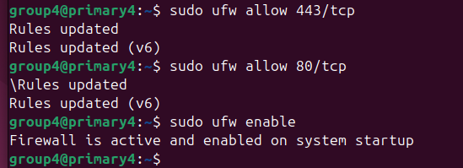
6. Verify our rules:
$ sudo ufw status numbered
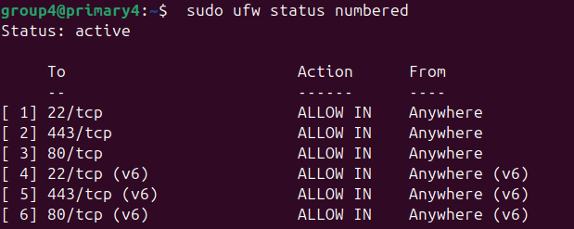
Testing (using virtual machine secondary4):
1. When allowing access (Using SSH service as example):
$ ssh group4@192.168.56.214 //primary’s Ip
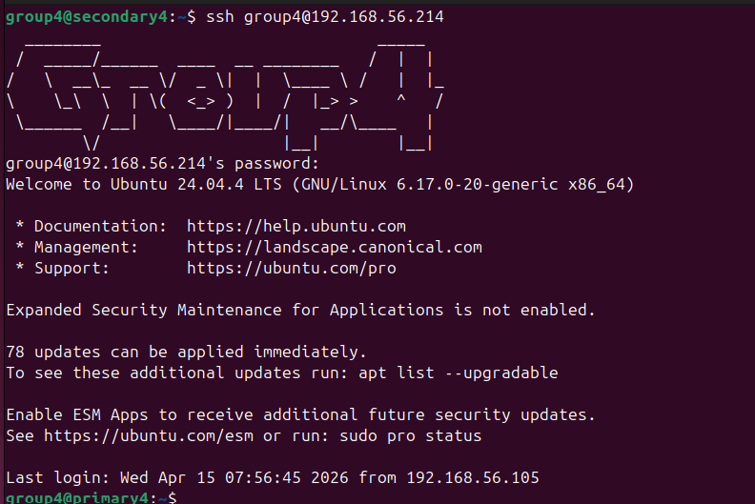
2. When denied access:
1. Apply deny to SSH port:
$ sudo ufw deny 22/tcp
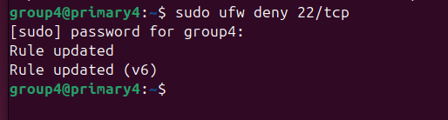
2. Test in secondary VM:
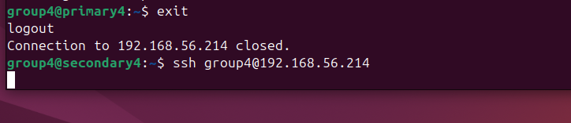
- Timed Out.

3. Re-open SSH after testing:
$sudo ufw delete deny 22/tcp
$sudo ufw allow 22/tcp
$sudo ufw reload
$sudo ufw status numbered
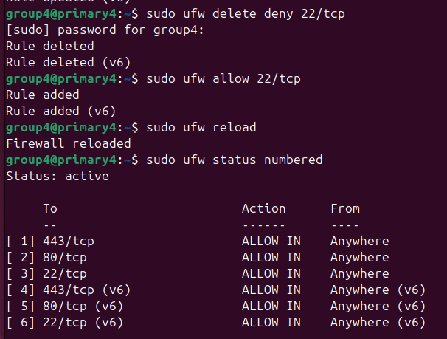

Fail2ban :
Benefits:
- Automatically detects repeated failed login attempts and bans the attacker’s IP.
- Reduces the risk of brute-force password attacks against SSH.
- Works well with UFW: UFW controls allowed ports, Fail2ban provides adaptive blocking on top of that.

1. Fail2ban installation:
$ sudo apt update
$ sudo apt install -y fail2ban
2. Enable and start the service:
$ sudo systemctl enable --now fail2ban //enable service
$ sudo systemctl status fail2ban --no-pager //check status (active)
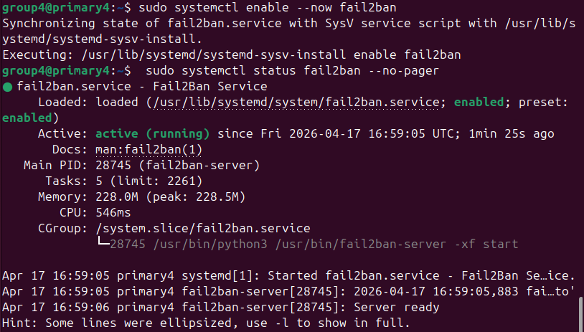
- Create jail rules (configs):
$ sudo nano /etc/fail2ban/jail.d/sshd.local

nano:
[sshd]
enabled = true
maxretry = 5
findtime = 10m
bantime = 30m
** maxtry = 5 : 5 fails within 10 minutes results ban.
bantime = 30m : ban period (30 minutes) or more.
- Restart service:
$ sudo systemctl restart fail2ban
- Testing:
$ sudo fail2ban-client status
$ sudo fail2ban-client status sshd
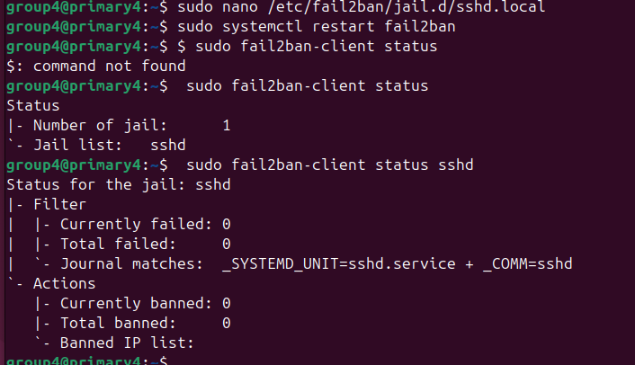
In secondary machine (Try failed login for 5 times) :
$ ssh group4@192.168.56.214 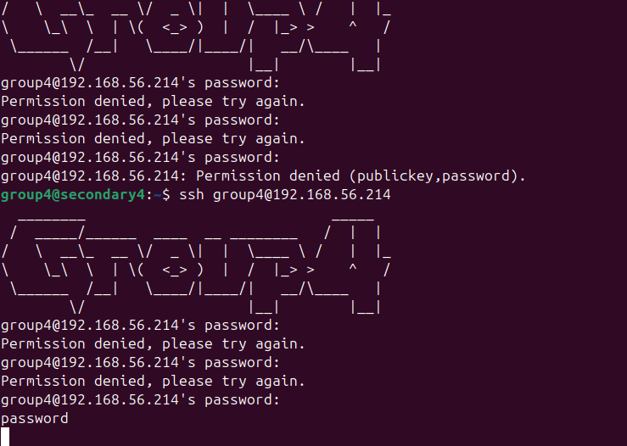
- Results a ban
- Check ban status:
$ sudo fail2ban-client status sshd
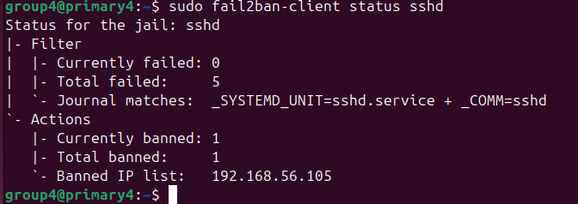

** Unban (In primary):
$ sudo fail2ban-client set sshd unbanip 192.168.56.105
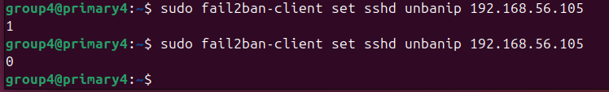
- Results “1” = unbanned 1 IP
- Results”0” = no ban record found

